Python Activity Based Learning
Selected Projects

Contents
1. Electricity Bill
2. Employee Payroll
3. Retail Bill
4. Examination Result
5. Attendance Recovery
6. ATM Transaction
7. Inventory Reconciliation
8. Water Tank Simulation
9. Number Diamond Pattern
10. Password Validator
Each project includes a problem statement, objectives, assumptions, algorithm, pseudocode, flowchart, source code, and conclusion.

Electricity Bill

Problem Statement
Calculate a household electricity bill from the number of units consumed. Use three unit slabs and add a fixed charge.

Objectives
To use input, arithmetic operations, if-else statements, and the min and max functions.

Assumptions
The first 100 units cost Rs. 1.50 per unit, the next 100 cost Rs. 2.50 per unit, and units above 200 cost Rs. 4 per unit. The fixed charge is Rs. 50. These are sample rates.

Program Screenshot
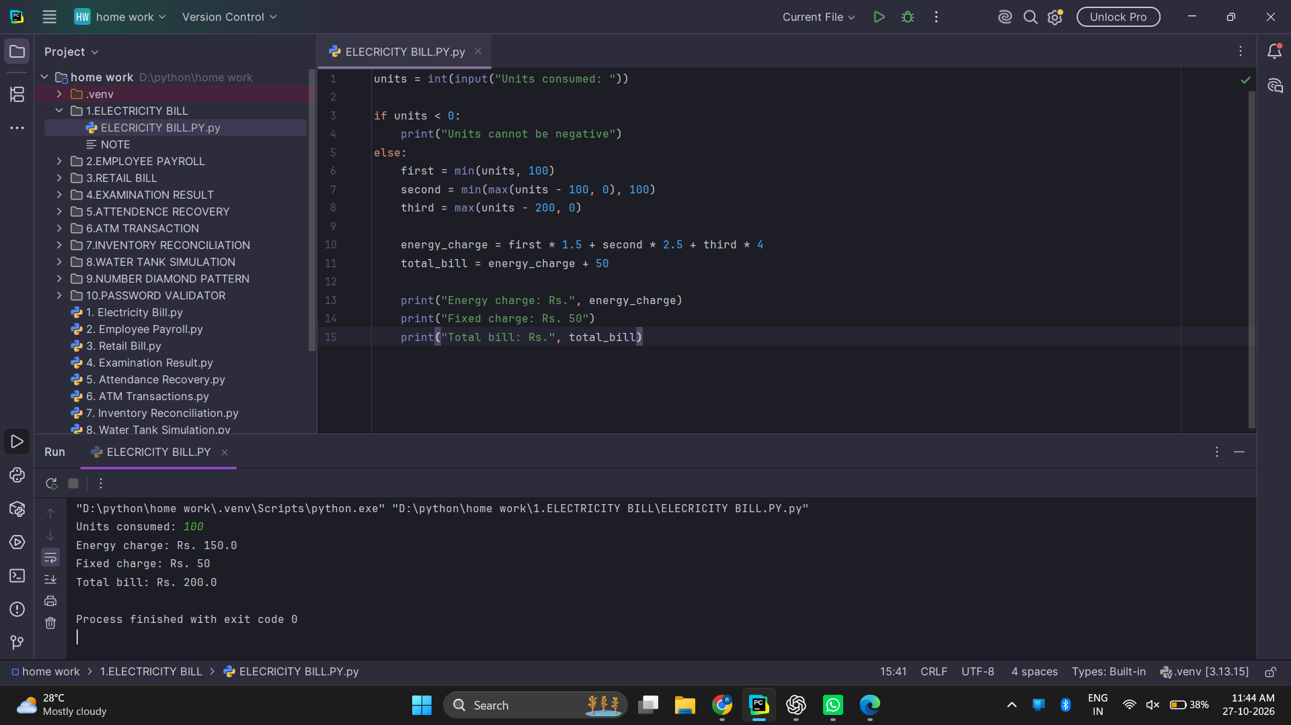

Electricity Bill - Algorithm and Pseudocode

Algorithm
- Start the program.
- Read the number of units.
- If units are negative, show an error message.
- Otherwise, calculate the charge for each slab.
- Add Rs. 50 to the energy charge.
- Display the energy charge and total bill.

Pseudocode
START
INPUT units
IF units < 0
DISPLAY "Units cannot be negative"
ELSE
first = minimum(units, 100)
second = minimum(maximum(units - 100, 0), 100)
third = maximum(units - 200, 0)
energy = first * 1.5 + second * 2.5 + third * 4
total = energy + 50
DISPLAY energy, fixed charge, total
END IF
STOP

Electricity Bill - Flowchart
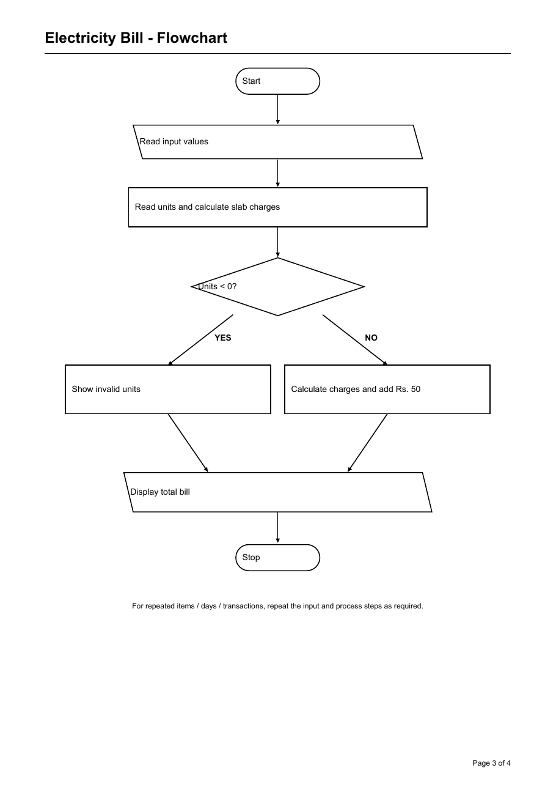
Oval: Start/Stop Slanted box: Input/Output Rectangle: Process Diamond: Decision

Electricity Bill - Python Source Code

Python Source Code
units = int(input("Units consumed: "))
if units < 0:
print("Units cannot be negative")
else:
first = min(units, 100)
second = min(max(units - 100, 0), 100)
third = max(units - 200, 0)
energy_charge = first * 1.5 + second * 2.5 + third * 4
total_bill = energy_charge + 50
print("Energy charge: Rs.", energy_charge)
print("Fixed charge: Rs. 50")
print("Total bill: Rs.", total_bill)

Test Cases and Program Output
Test Case 1
Input: 100 units
Expected Output: Energy Rs. 150; fixed Rs. 50; total Rs. 200
Test Case 2
Input: -5 units
Expected Output: Units cannot be negative

Conclusion
The program calculates a bill from unit slabs and displays the total amount.

Employee Payroll

Problem Statement
Calculate an employee's gross pay, deduction, and net pay using basic pay, allowances, and overtime.

Objectives
To practice input, variables, arithmetic, and progressive deductions.

Assumptions
Five percent is deducted from the first Rs. 20,000 of gross pay and 10% from any amount above Rs. 20,000. The rates are for this exercise.

Program Screenshot
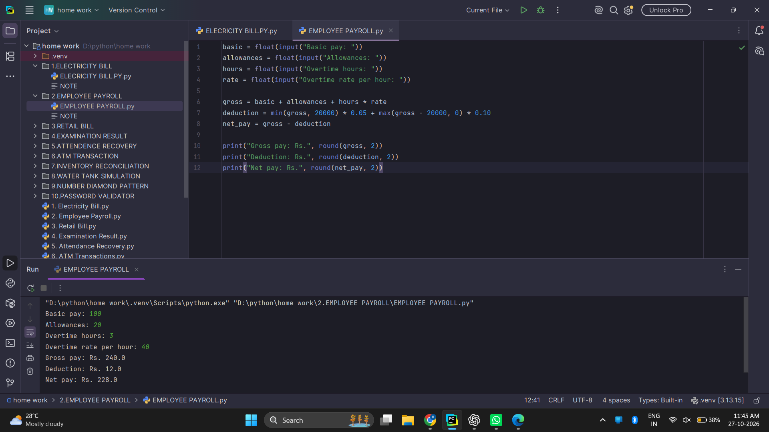

Employee Payroll - Algorithm and Pseudocode

Algorithm
- Read basic pay, allowances, overtime hours, and overtime rate.
- Calculate overtime pay.
- Add basic pay, allowances, and overtime pay.
- Calculate the deduction for both pay ranges.
- Subtract the deduction from gross pay.
- Display gross pay, deduction, and net pay.

Pseudocode
START
INPUT basic, allowances, hours, rate
overtime_pay = hours * rate
gross = basic + allowances + overtime_pay
first_part = minimum(gross, 20000)
extra_part = maximum(gross - 20000, 0)
deduction = first_part * 0.05 + extra_part * 0.10
net_pay = gross - deduction
DISPLAY gross, deduction, net_pay
STOP

Employee Payroll - Flowchart
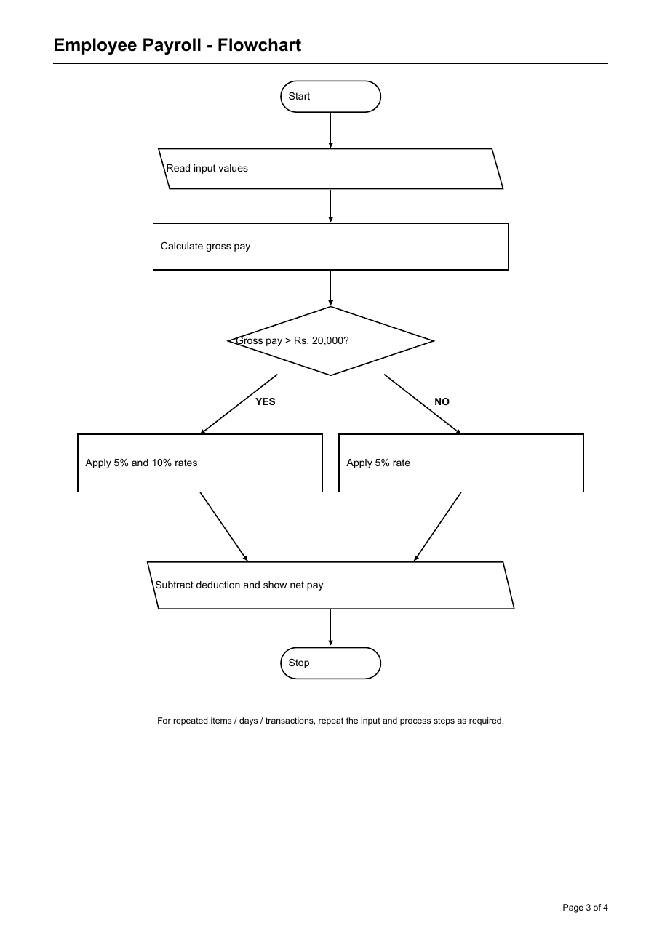
Oval: Start/Stop Slanted box: Input/Output Rectangle: Process Diamond: Decision

Employee Payroll - Python Source Code

Python Source Code
basic = float(input("Basic pay: "))
allowances = float(input("Allowances: "))
hours = float(input("Overtime hours: "))
rate = float(input("Overtime rate per hour: "))
gross = basic + allowances + hours * rate
deduction = min(gross, 20000) * 0.05 + max(gross - 20000, 0) * 0.10
net_pay = gross - deduction
print("Gross pay: Rs.", round(gross, 2))
print("Deduction: Rs.", round(deduction, 2))
print("Net pay: Rs.", round(net_pay, 2))

Test Cases and Program Output
Test Case 1
Input: Basic 100, allowance 20, 3 hours at 40
Expected Output: Gross Rs. 240; deduction Rs. 12; net Rs. 228
Test Case 2
Input: All inputs zero
Expected Output: Gross Rs. 0; deduction Rs. 0; net Rs. 0

Conclusion
The program adds salary components, calculates the deduction, and prints the take-home pay.

Retail Bill

Problem Statement
Prepare a bill for several products using their prices and quantities. Apply a discount when the subtotal reaches the given limit, then add tax.

Objectives
To use a loop, input, multiplication, addition, and a conditional expression.

Assumptions
A 10% discount applies when the subtotal is at least Rs. 2,000. Tax is 5% of the amount after discount. Rates are examples for this activity.

Program Screenshot
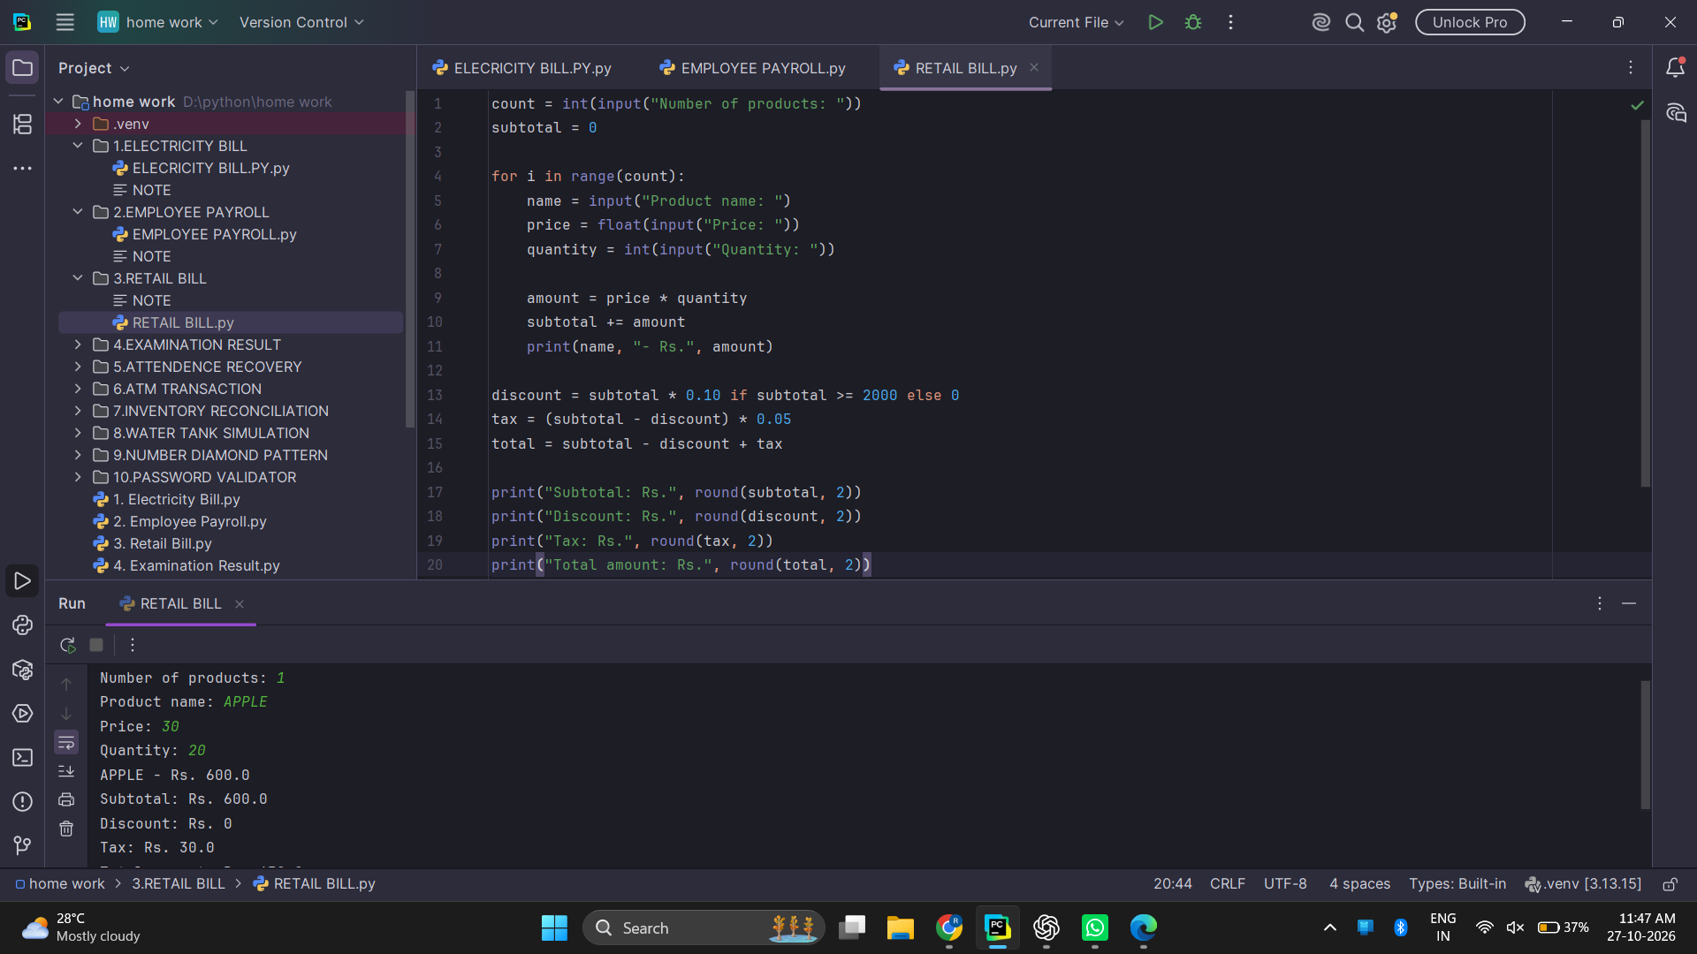

Retail Bill - Algorithm and Pseudocode

Algorithm
- Read the number of products.
- For each product, read name, price, and quantity.
- Calculate the item amount and add it to subtotal.
- If subtotal is Rs. 2,000 or more, calculate a 10% discount.
- Calculate 5% tax on the discounted amount.
- Display subtotal, discount, tax, and total.

Pseudocode
START
INPUT product_count
subtotal = 0
FOR each product
INPUT name, price, quantity
amount = price * quantity
subtotal = subtotal + amount
DISPLAY name, amount
END FOR
IF subtotal >= 2000, discount = subtotal * 0.10
ELSE discount = 0
tax = (subtotal - discount) * 0.05
total = subtotal - discount + tax
DISPLAY subtotal, discount, tax, total
STOP

Retail Bill - Flowchart
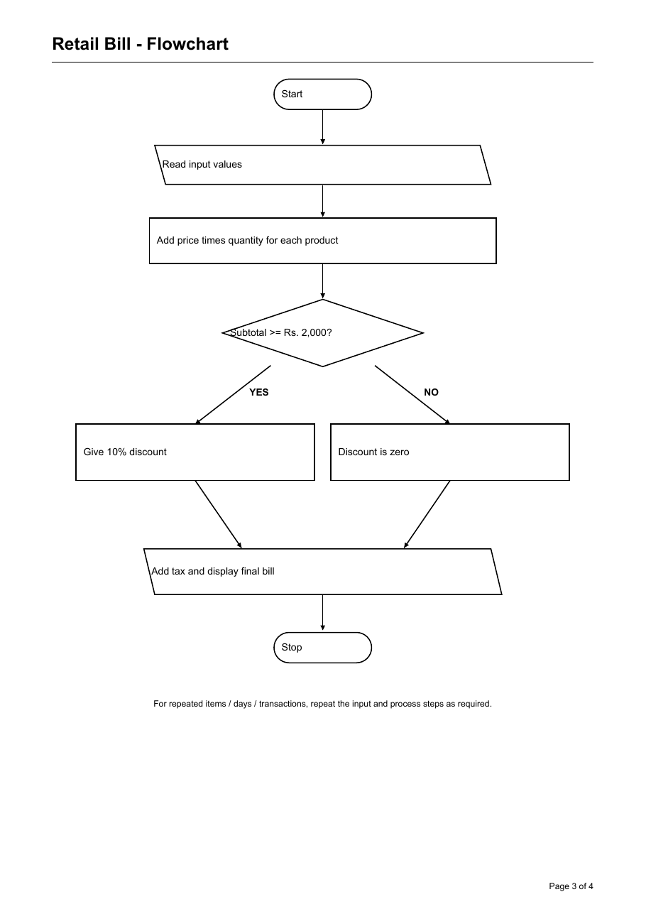
Oval: Start/Stop Slanted box: Input/Output Rectangle: Process Diamond: Decision

Retail Bill - Python Source Code

Python Source Code
count = int(input("Number of products: "))
subtotal = 0
for i in range(count):
name = input("Product name: ")
price = float(input("Price: "))
quantity = int(input("Quantity: "))
amount = price * quantity
subtotal += amount
print(name, "- Rs.", amount)
discount = subtotal * 0.10 if subtotal >= 2000 else 0
tax = (subtotal - discount) * 0.05
total = subtotal - discount + tax
print("Subtotal: Rs.", round(subtotal, 2))
print("Discount: Rs.", round(discount, 2))
print("Tax: Rs.", round(tax, 2))
print("Total amount: Rs.", round(total, 2))

Test Cases and Program Output
Test Case 1
Input: 1 product: price 30, quantity 20
Expected Output: Subtotal Rs. 600; discount Rs. 0; tax Rs. 30; total Rs. 630
Test Case 2
Input: Subtotal Rs. 2,000
Expected Output: Discount Rs. 200 before tax

Conclusion
The program adds the item amounts and applies the discount and tax rules to make a final bill.

Examination Result

Problem Statement
Read marks for three subjects, check that they are valid, and display the student's result class.

Objectives
To use lists, loops, conditions, sum, average, and pass criteria.

Assumptions
Marks are out of 100. A score below 35 in any subject is a fail. The average boundaries in the code decide the result class.

Program Screenshot
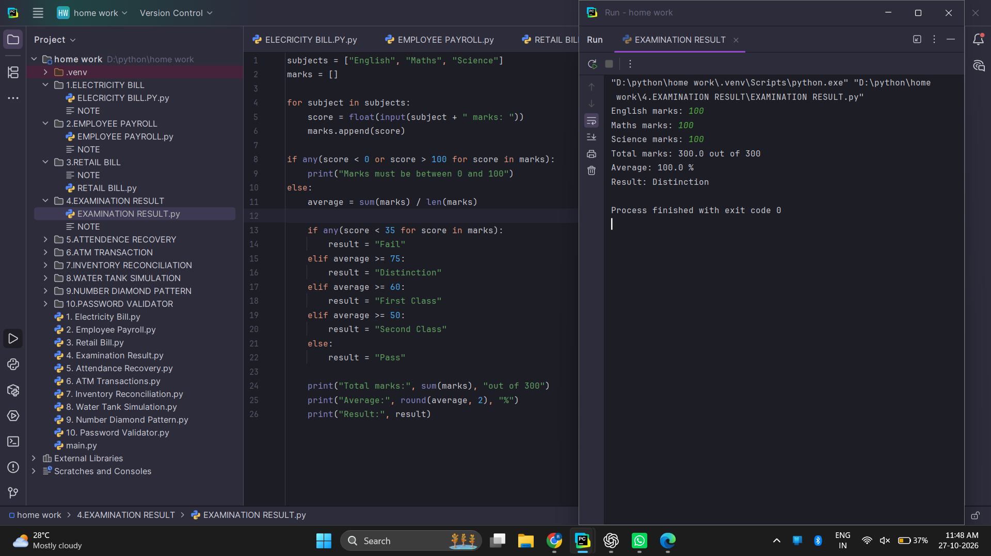

Examination Result - Algorithm and Pseudocode

Algorithm
- Read marks for English, Maths, and Science.
- Check that every mark is between 0 and 100.
- If a mark is invalid, display an error.
- Otherwise calculate total and average.
- If any mark is below 35, set result to Fail.
- Otherwise choose the class using the average.
- Display total, average, and result.

Pseudocode
START
subjects = English, Maths, Science
INPUT marks for each subject
IF any mark < 0 OR any mark > 100
DISPLAY invalid marks
ELSE
average = total marks / 3
IF any mark < 35, result = Fail
ELSE IF average >= 75, result = Distinction
ELSE IF average >= 60, result = First Class
ELSE IF average >= 50, result = Second Class
ELSE result = Pass
DISPLAY total, average, result
END IF
STOP

Examination Result - Flowchart
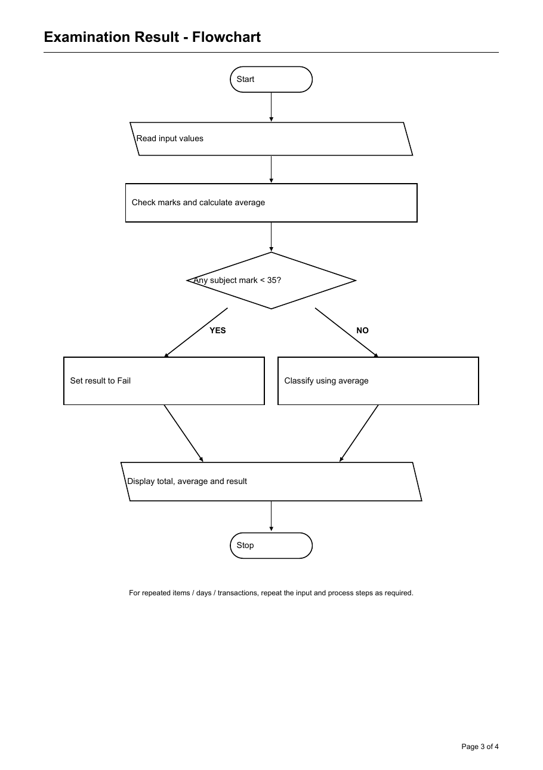
Oval: Start/Stop Slanted box: Input/Output Rectangle: Process Diamond: Decision

Examination Result - Python Source Code

Python Source Code
subjects = ["English", "Maths", "Science"]
marks = []
for subject in subjects:
score = float(input(subject + " marks: "))
marks.append(score)
if any(score < 0 or score > 100 for score in marks):
print("Marks must be between 0 and 100")
else:
average = sum(marks) / len(marks)
if any(score < 35 for score in marks):
result = "Fail"
elif average >= 75:
result = "Distinction"
elif average >= 60:
result = "First Class"
elif average >= 50:
result = "Second Class"
else:
result = "Pass"
print("Total marks:", sum(marks), "out of 300")
print("Average:", round(average, 2), "%")
print("Result:", result)

Test Cases and Program Output
Test Case 1
Input: 100, 100, 100
Expected Output: Total 300; average 100%; Distinction
Test Case 2
Input: 30, 80, 80
Expected Output: Fail because one mark is below 35

Conclusion
The program checks each subject and then displays the result based on the pass rule and average.

Attendance Recovery

Problem Statement
Calculate current attendance and find how many consecutive classes are needed to reach the required percentage.

Objectives
To use input validation, percentages, conditions, and arithmetic.

Assumptions
Only future classes that are all attended are counted. If the required percentage is 100 and a past class was missed, the program reports that 100% cannot be reached.

Program Screenshot
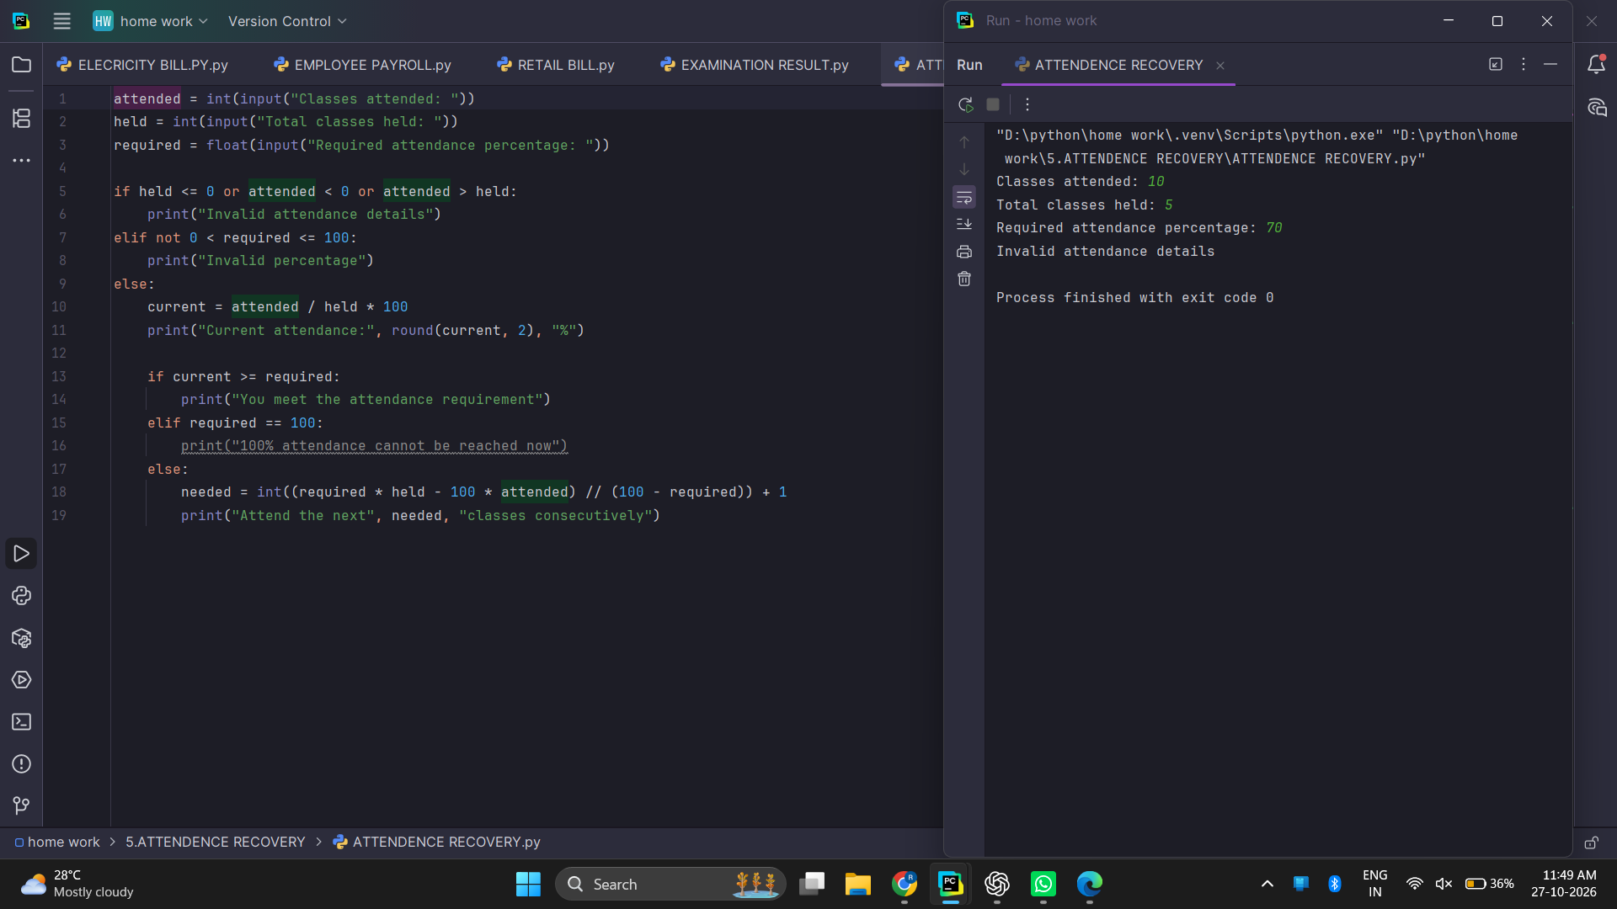

Attendance Recovery - Algorithm and Pseudocode

Algorithm
- Read attended classes, classes held, and required percentage.
- Check that the numbers are valid.
- Calculate the current attendance percentage.
- If the target is already met, display that it is met.
- If the target is 100%, display the special message.
- Otherwise calculate the number of classes to attend in a row.
- Display the result.

Pseudocode
START
INPUT attended, held, required
IF held <= 0 OR attended < 0 OR attended > held
DISPLAY invalid attendance details
ELSE IF required <= 0 OR required > 100
DISPLAY invalid percentage
ELSE
current = attended / held * 100
IF current >= required, DISPLAY requirement met
ELSE IF required = 100, DISPLAY cannot reach 100%
ELSE calculate consecutive classes needed
DISPLAY current attendance and answer
END IF
STOP

Attendance Recovery - Flowchart
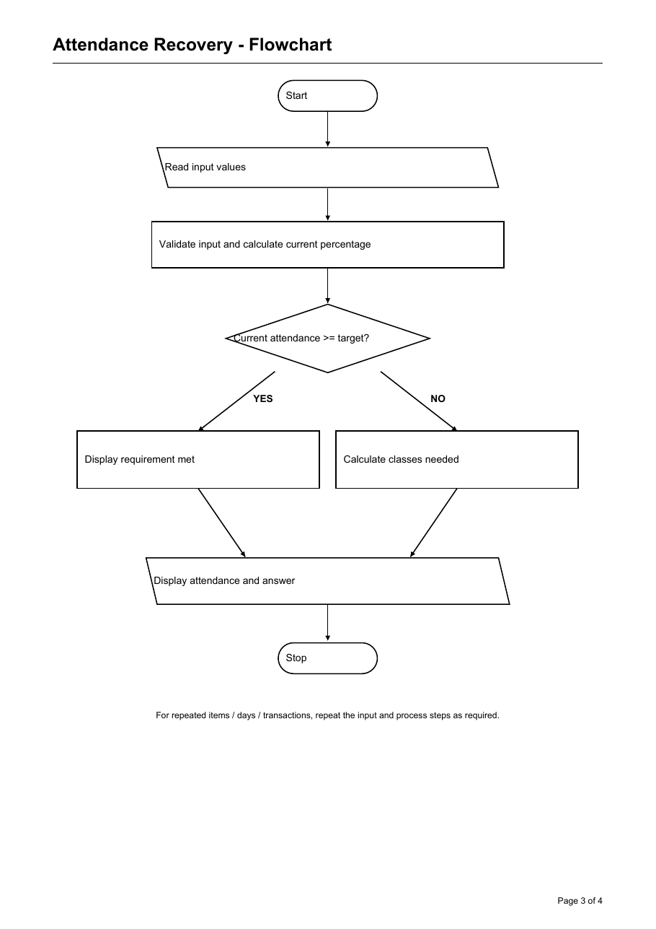
Oval: Start/Stop Slanted box: Input/Output Rectangle: Process Diamond: Decision

Attendance Recovery - Python Source Code

Python Source Code
attended = int(input("Classes attended: "))
held = int(input("Total classes held: "))
required = float(input("Required attendance percentage: "))
if held <= 0 or attended < 0 or attended > held:
print("Invalid attendance details")
elif not 0 < required <= 100:
print("Invalid percentage")
else:
current = attended / held * 100
print("Current attendance:", round(current, 2), "%")
if current >= required:
print("You meet the attendance requirement")
elif required == 100:
print("100% attendance cannot be reached now")
else:
needed = int((required * held - 100 * attended) // (100 - required)) + 1
print("Attend the next", needed, "classes consecutively")

Test Cases and Program Output
Test Case 1
Input: 10 attended, 5 held, target 70%
Expected Output: Invalid attendance details
Test Case 2
Input: 10 attended, 20 held, target 70%
Expected Output: Current 50%; attend next 14 classes

Conclusion
The program checks the attendance data and tells the student whether the target is met or how many classes are needed.

ATM Transaction

Problem Statement
Simulate deposits and withdrawals, update the balance, and display transaction totals when the user finishes.

Objectives
To use a while loop, conditions, arithmetic, and input/output.

Assumptions
This is a practice simulation. Deposits and withdrawals must be positive. A withdrawal cannot be more than the current balance.

Program Screenshot
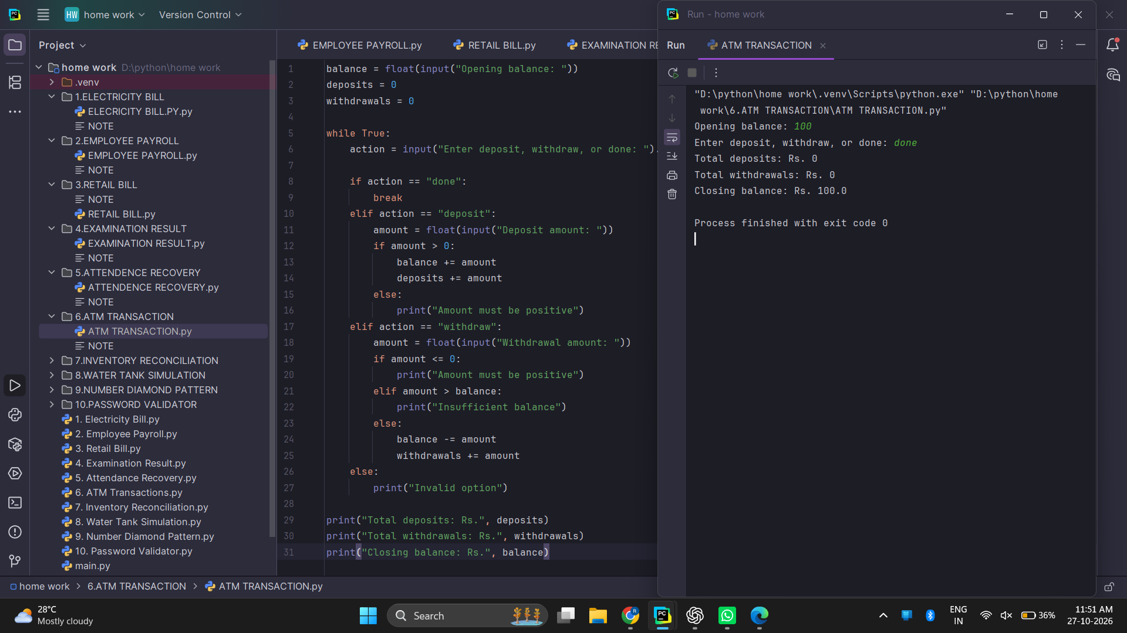

ATM Transaction - Algorithm and Pseudocode

Algorithm
- Read the opening balance and set deposit and withdrawal totals to zero.
- Ask for deposit, withdraw, or done.
- If done, stop taking transactions.
- For a deposit, check the amount and add it to the balance.
- For a withdrawal, check the amount and available balance.
- Repeat the menu until done.
- Display totals and closing balance.

Pseudocode
START
INPUT opening_balance
deposits = 0; withdrawals = 0
WHILE true
INPUT action
IF action = done, EXIT LOOP
IF action = deposit, read amount and add if positive
ELSE IF action = withdraw
read amount
IF amount <= 0, display error
ELSE IF amount > balance, display insufficient balance
ELSE subtract amount and add to withdrawals
END WHILE
DISPLAY deposits, withdrawals, closing balance
STOP

ATM Transaction - Flowchart
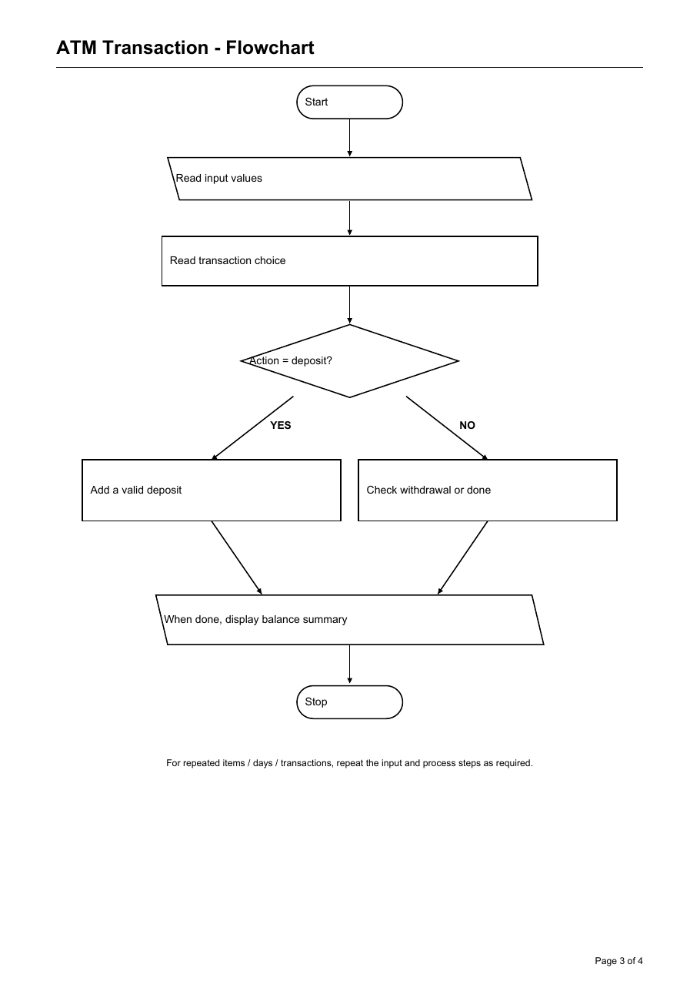
Oval: Start/Stop Slanted box: Input/Output Rectangle: Process Diamond: Decision

ATM Transaction - Python Source Code

Python Source Code
balance = float(input("Opening balance: "))
deposits = 0
withdrawals = 0
while True:
action = input("Enter deposit, withdraw, or done: ").lower()
if action == "done":
break
elif action == "deposit":
amount = float(input("Deposit amount: "))
if amount > 0:
balance += amount
deposits += amount
else:
print("Amount must be positive")
elif action == "withdraw":
amount = float(input("Withdrawal amount: "))
if amount <= 0:
print("Amount must be positive")
elif amount > balance:
print("Insufficient balance")
else:
balance -= amount
withdrawals += amount
else:
print("Invalid option")
print("Total deposits: Rs.", deposits)
print("Total withdrawals: Rs.", withdrawals)
print("Closing balance: Rs.", balance)

Test Cases and Program Output
Test Case 1
Input: Opening Rs. 100; enter done
Expected Output: Deposits 0; withdrawals 0; closing balance Rs. 100
Test Case 2
Input: Opening Rs. 100; withdraw Rs. 150
Expected Output: Withdrawal declined: insufficient balance

Conclusion
The program processes each valid transaction and keeps the account balance updated.

Inventory Reconciliation

Problem Statement
Compare recorded closing stock with the stock expected from opening stock, receipts, and dispatches.

Objectives
To use a list, a loop, arithmetic, conditions, and stock comparison.

Assumptions
The product list contains Notebooks, Pens, and Folders. The desired minimum stock is 20 units.

Program Screenshot
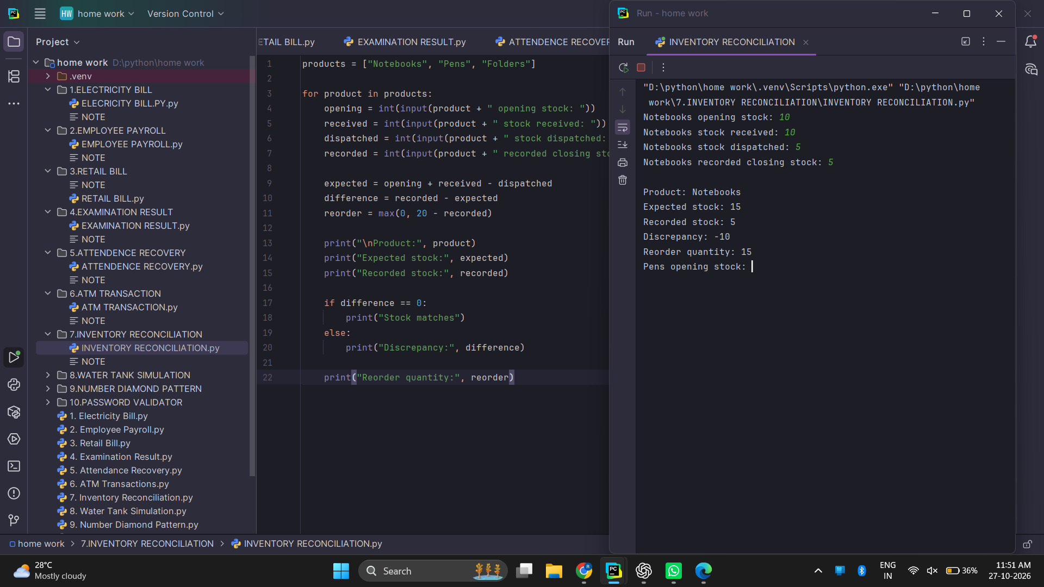

Inventory Reconciliation - Algorithm and Pseudocode

Algorithm
- For each product, read opening, received, dispatched, and recorded stock.
- Calculate expected closing stock.
- Find the difference between recorded and expected stock.
- Check whether the stock matches.
- Calculate how many units are needed to reach 20.
- Display the stock report.

Pseudocode
START
products = Notebooks, Pens, Folders
FOR each product
INPUT opening, received, dispatched, recorded
expected = opening + received - dispatched
difference = recorded - expected
reorder = maximum(0, 20 - recorded)
IF difference = 0, DISPLAY stock matches
ELSE DISPLAY discrepancy
DISPLAY expected stock and reorder
END FOR
STOP

Inventory Reconciliation - Flowchart
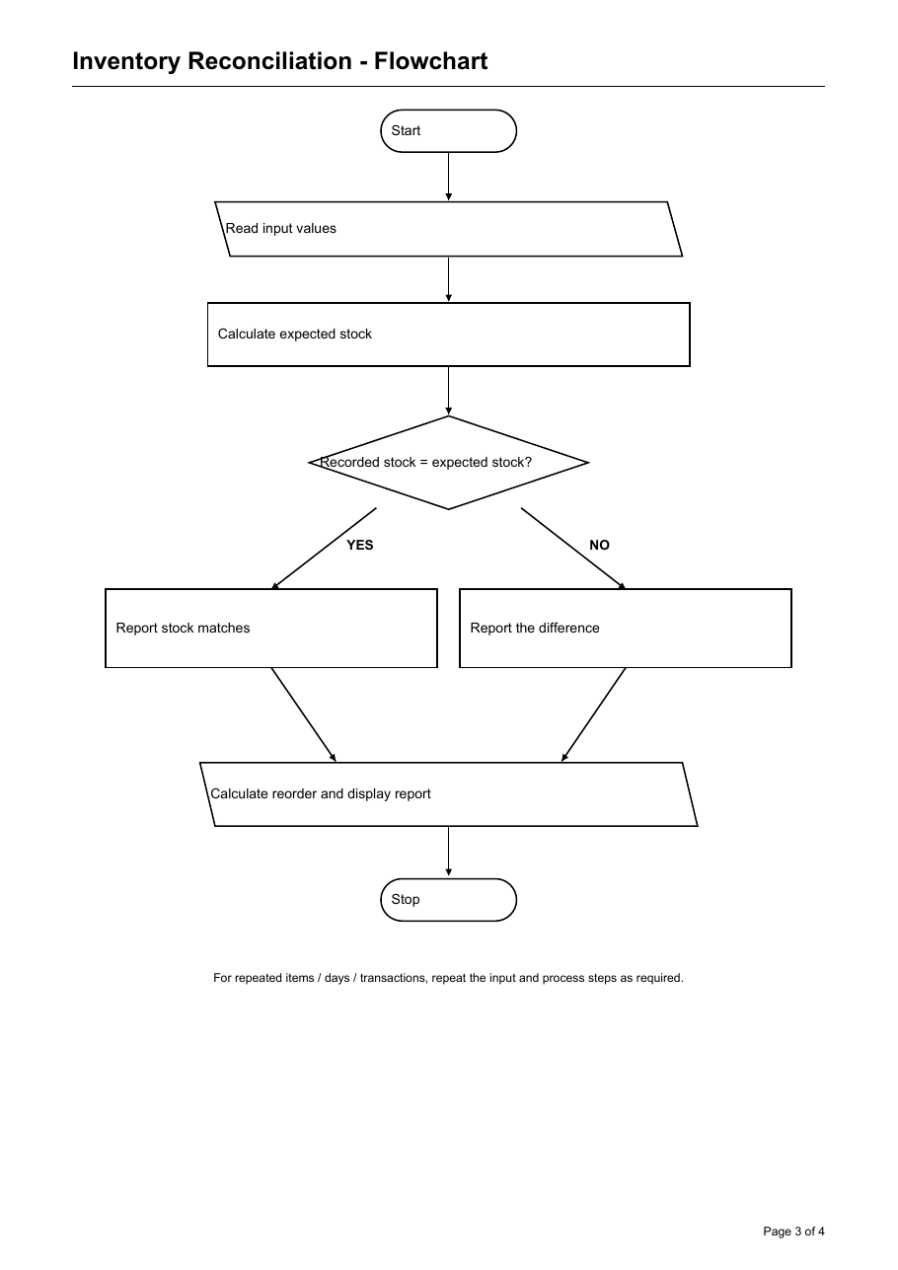
Oval: Start/Stop Slanted box: Input/Output Rectangle: Process Diamond: Decision

Inventory Reconciliation - Python Source Code

Python Source Code
products = ["Notebooks", "Pens", "Folders"]
for product in products:
opening = int(input(product + " opening stock: "))
received = int(input(product + " stock received: "))
dispatched = int(input(product + " stock dispatched: "))
recorded = int(input(product + " recorded closing stock: "))
expected = opening + received - dispatched
difference = recorded - expected
reorder = max(0, 20 - recorded)
print("\nProduct:", product)
print("Expected stock:", expected)
print("Recorded stock:", recorded)
if difference == 0:
print("Stock matches")
else:
print("Discrepancy:", difference)
print("Reorder quantity:", reorder)

Test Cases and Program Output
Test Case 1
Input: Notebooks: opening 10, received 10, dispatched 5, recorded 5
Expected Output: Expected 15; discrepancy -10; reorder 15
Test Case 2
Input: Recorded stock 20
Expected Output: Reorder quantity 0

Conclusion
The program finds stock differences and shows the quantity needed to reach the chosen minimum.

Water Tank Simulation

Problem Statement
Update a tank's water level over several days using daily inflow and outflow.

Objectives
To use a loop, arithmetic, conditions, and limits on a value.

Assumptions
The water level cannot be below zero or above tank capacity after each day. Water is measured in litres.

Program Screenshot
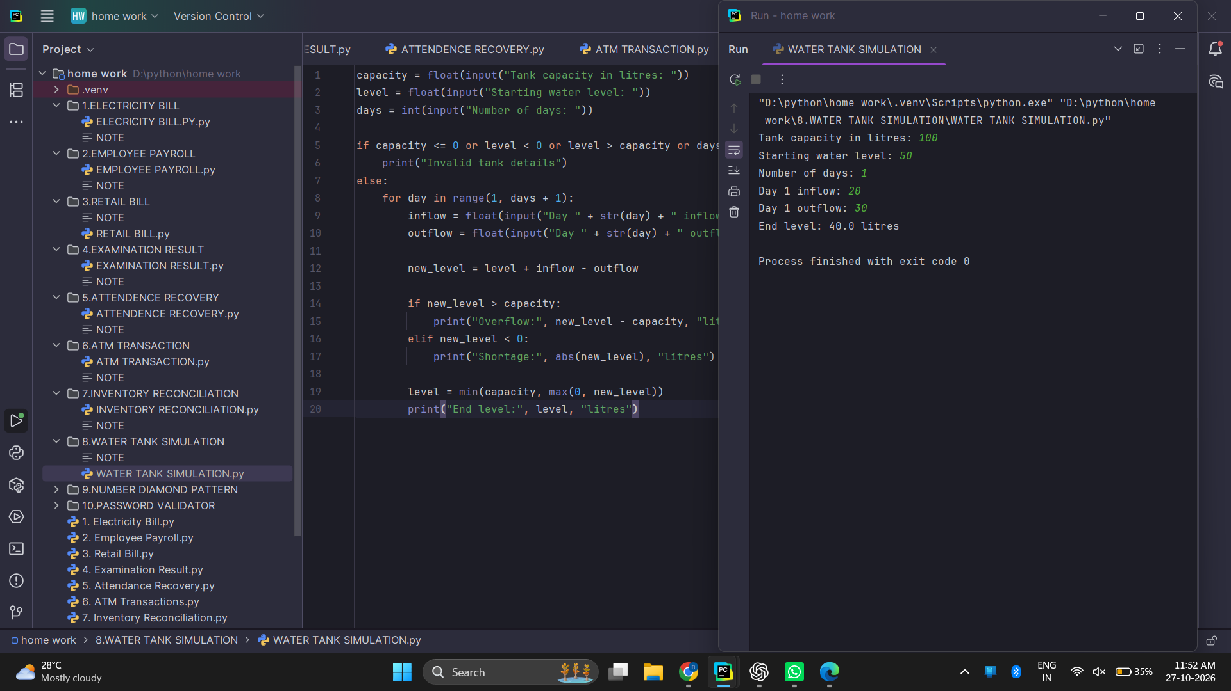

Water Tank Simulation - Algorithm and Pseudocode

Algorithm
- Read tank capacity, starting level, and number of days.
- Check the tank details.
- For each day, read inflow and outflow.
- Calculate the new level.
- Report overflow or shortage if needed.
- Keep the stored level between zero and capacity.
- Display the end level.

Pseudocode
START
INPUT capacity, level, days
IF tank details are invalid, DISPLAY error
ELSE FOR each day
INPUT inflow, outflow
new_level = level + inflow - outflow
IF new_level > capacity, DISPLAY overflow
ELSE IF new_level < 0, DISPLAY shortage
level = minimum(capacity, maximum(0, new_level))
DISPLAY level
END FOR
STOP

Water Tank Simulation - Flowchart
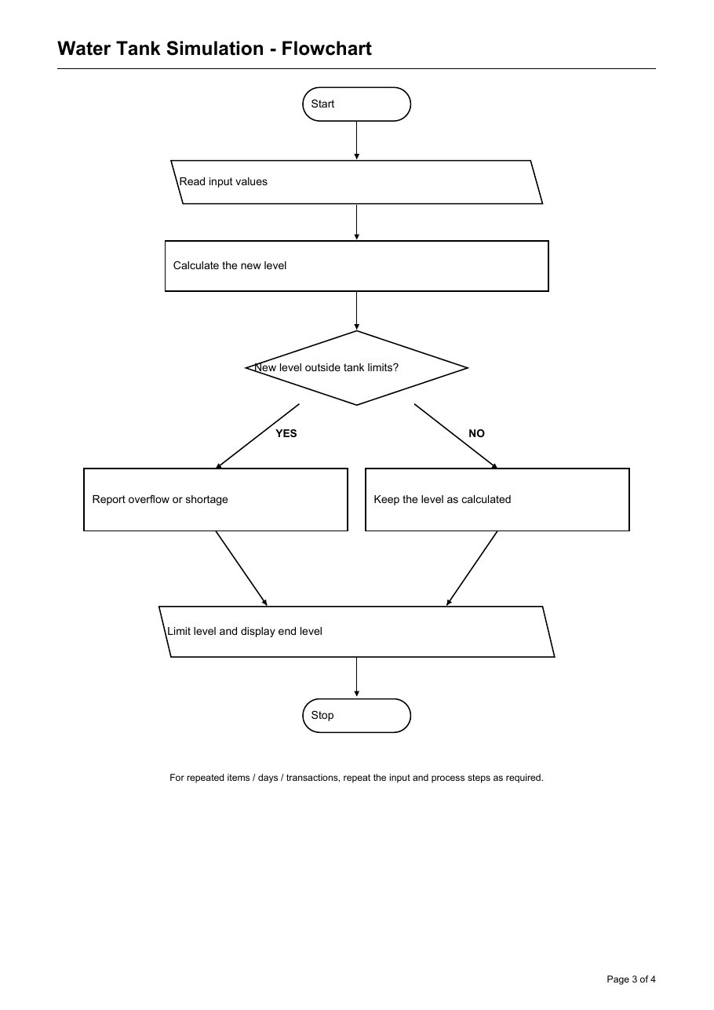
Oval: Start/Stop Slanted box: Input/Output Rectangle: Process Diamond: Decision

Water Tank Simulation - Python Source Code

Python Source Code
capacity = float(input("Tank capacity in litres: "))
level = float(input("Starting water level: "))
days = int(input("Number of days: "))
if capacity <= 0 or level < 0 or level > capacity or days < 0:
print("Invalid tank details")
else:
for day in range(1, days + 1):
inflow = float(input("Day " + str(day) + " inflow: "))
outflow = float(input("Day " + str(day) + " outflow: "))
new_level = level + inflow - outflow
if new_level > capacity:
print("Overflow:", new_level - capacity, "litres")
elif new_level < 0:
print("Shortage:", abs(new_level), "litres")
level = min(capacity, max(0, new_level))
print("End level:", level, "litres")

Test Cases and Program Output
Test Case 1
Input: Capacity 100, start 50, inflow 20, outflow 30
Expected Output: End level 40 litres
Test Case 2
Input: Capacity 100, start 90, inflow 20, outflow 0
Expected Output: Overflow 10 litres; end level 100 litres

Conclusion
The program tracks water each day and reports when the level goes outside the tank capacity.

Number Diamond Pattern

Problem Statement
Print a centered diamond pattern using number rows that grow and then shrink.

Objectives
To use nested loops, range, strings, and pattern generation.

Assumptions
The half-height must be an integer from 1 to 9. Spaces are added before each row to center the pattern.

Program Screenshot
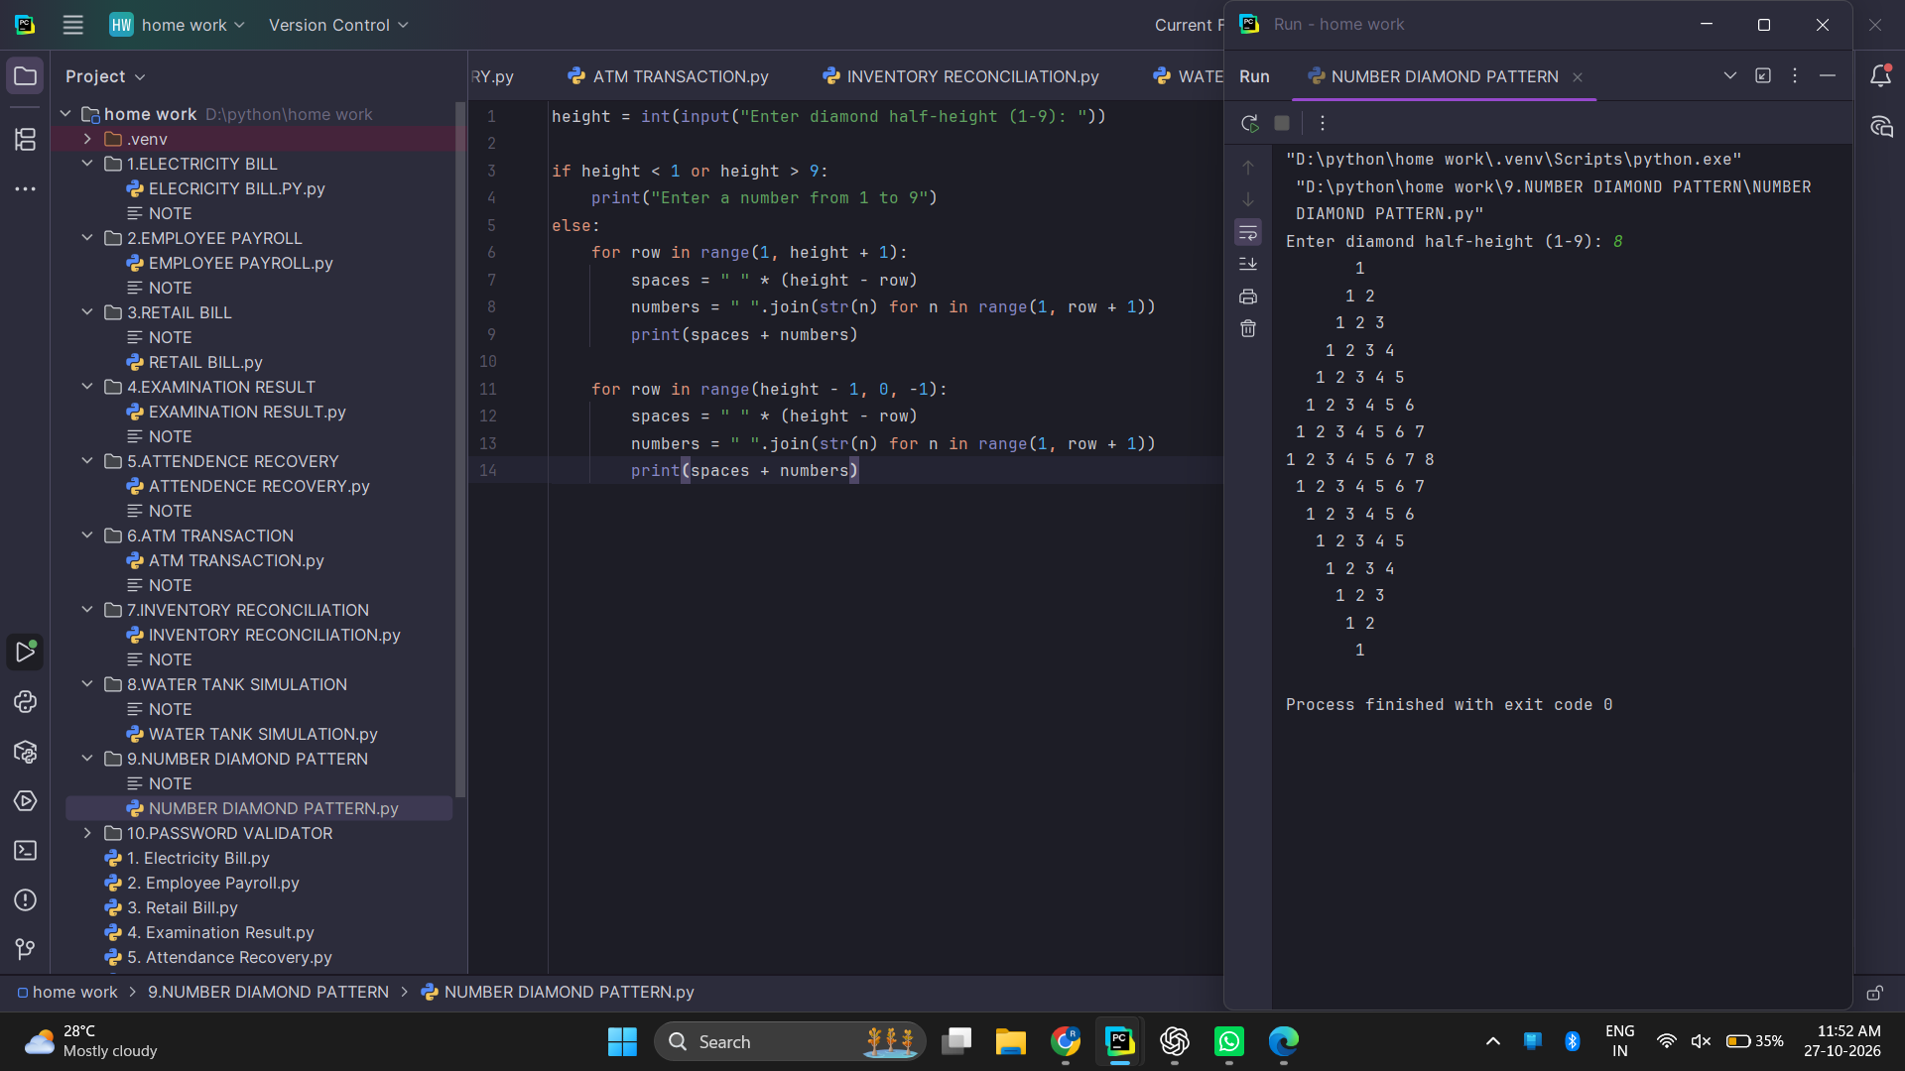

Number Diamond Pattern - Algorithm and Pseudocode

Algorithm
- Read the diamond half-height.
- If it is outside 1 to 9, display an error.
- Print rows from 1 up to the height.
- Print rows from height minus 1 back down to 1.
- Stop after the diamond is printed.

Pseudocode
START
INPUT height
IF height < 1 OR height > 9
DISPLAY invalid height
ELSE
FOR row = 1 TO height
Print height - row spaces and numbers 1 to row
END FOR
FOR row = height - 1 DOWN TO 1
Print height - row spaces and numbers 1 to row
END FOR
END IF
STOP

Number Diamond Pattern - Flowchart
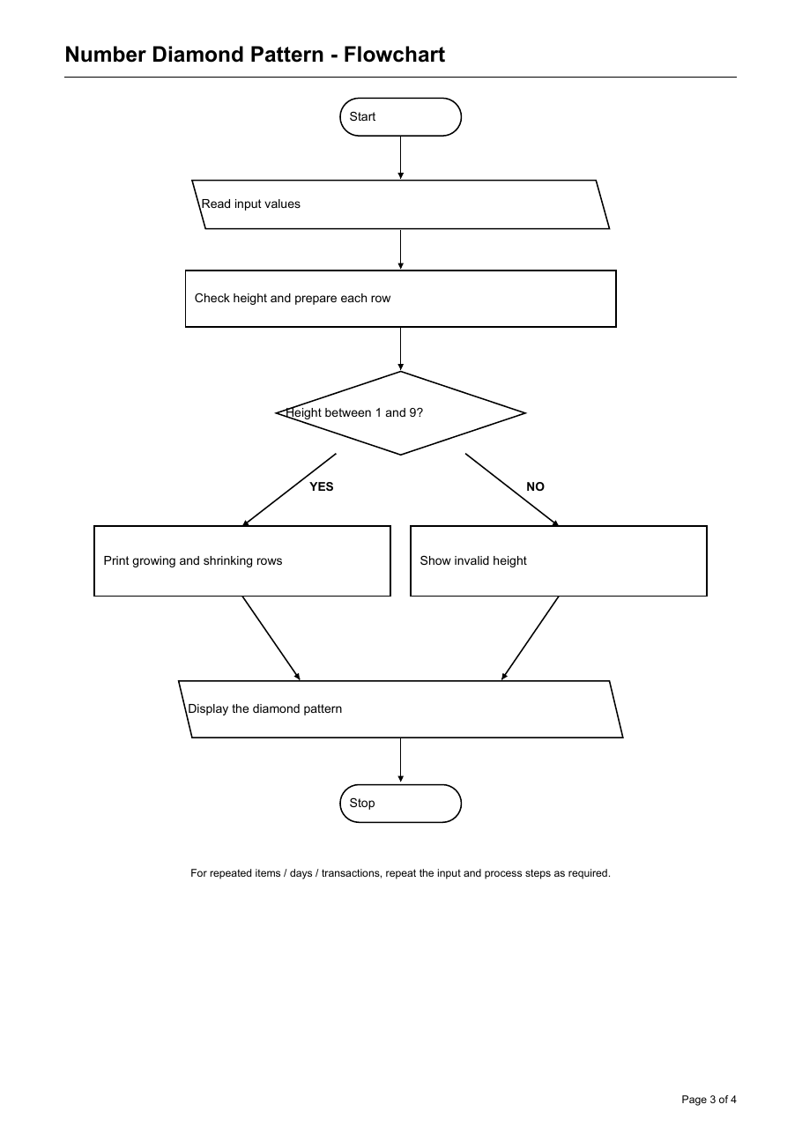
Oval: Start/Stop Slanted box: Input/Output Rectangle: Process Diamond: Decision

Number Diamond Pattern - Python Source Code

Python Source Code
height = int(input("Enter diamond half-height (1-9): "))
if height < 1 or height > 9:
print("Enter a number from 1 to 9")
else:
for row in range(1, height + 1):
spaces = " " * (height - row)
numbers = " ".join(str(n) for n in range(1, row + 1))
print(spaces + numbers)
for row in range(height - 1, 0, -1):
spaces = " " * (height - row)
numbers = " ".join(str(n) for n in range(1, row + 1))
print(spaces + numbers)

Test Cases and Program Output
Test Case 1
Input: Height 3
Expected Output: Rows: 1 / 1 2 / 1 2 3 / 1 2 / 1
Test Case 2
Input: Height 0
Expected Output: Enter a number from 1 to 9

Conclusion
The two loops print the upper and lower halves of the number diamond.

Password Validator

Problem Statement
Check whether a password meets the length and character rules in the program.

Objectives
To use strings, lists, loops, conditions, and character checks.

Assumptions
A valid password has at least 8 characters, one lowercase letter, one uppercase letter, and one digit. It must not contain the word password.

Program Screenshot
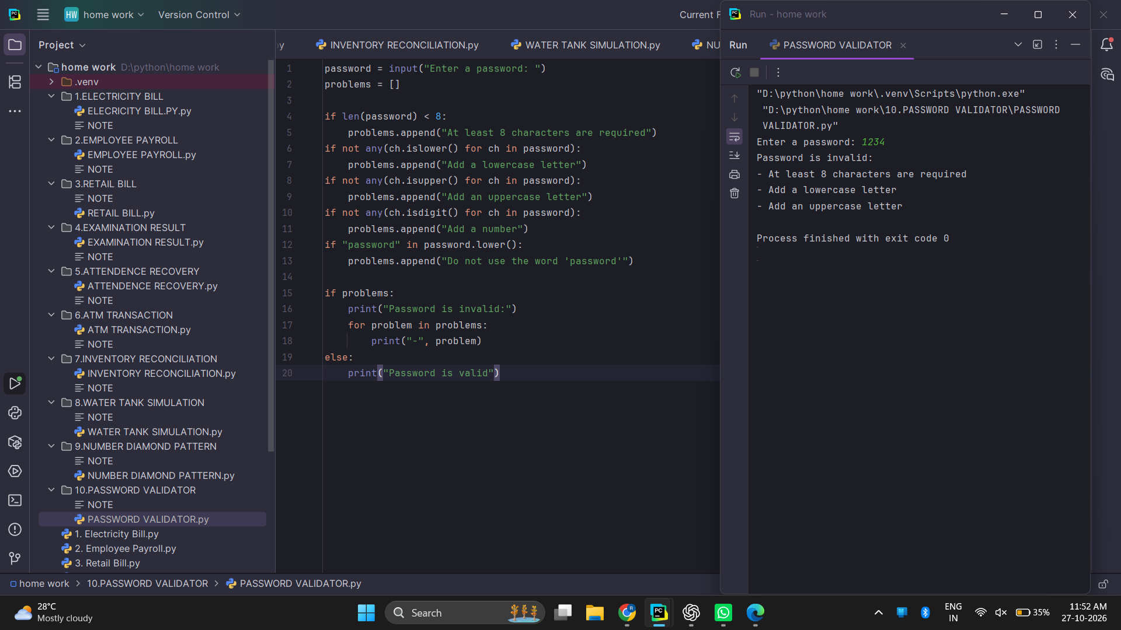

Password Validator - Algorithm and Pseudocode

Algorithm
- Read the password and create an empty list of problems.
- Check its length.
- Check for lowercase, uppercase, and digit characters.
- Check that it does not contain the word password.
- Add a message for each rule that fails.
- Display valid or list the problems.

Pseudocode
START
INPUT password
problems = empty list
IF length < 8, add length message
IF no lowercase, add lowercase message
IF no uppercase, add uppercase message
IF no digit, add digit message
IF password contains "password", add warning
IF problems is empty, DISPLAY valid
ELSE DISPLAY each problem
STOP

Password Validator - Flowchart
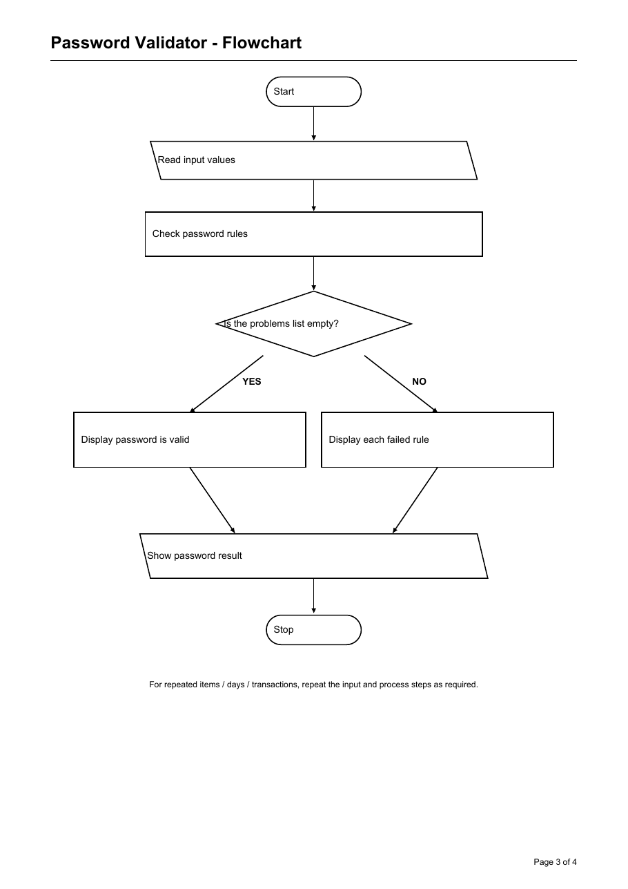
Oval: Start/Stop Slanted box: Input/Output Rectangle: Process Diamond: Decision

Password Validator - Python Source Code

Python Source Code
password = input("Enter a password: ")
problems = []
if len(password) < 8:
problems.append("At least 8 characters are required")
if not any(ch.islower() for ch in password):
problems.append("Add a lowercase letter")
if not any(ch.isupper() for ch in password):
problems.append("Add an uppercase letter")
if not any(ch.isdigit() for ch in password):
problems.append("Add a number")
if "password" in password.lower():
problems.append("Do not use the word 'password'")
if problems:
print("Password is invalid:")
for problem in problems:
print("-", problem)
else:
print("Password is valid")

Test Cases and Program Output
Test Case 1
Input: Password 1234
Expected Output: Invalid: too short; missing lowercase and uppercase letters
Test Case 2
Input: Password Abc12345
Expected Output: Invalid: contains the word password
Test Case 3
Input: Password Study123
Expected Output: Valid under these rules

Conclusion
The program reports each rule the password does not meet.

